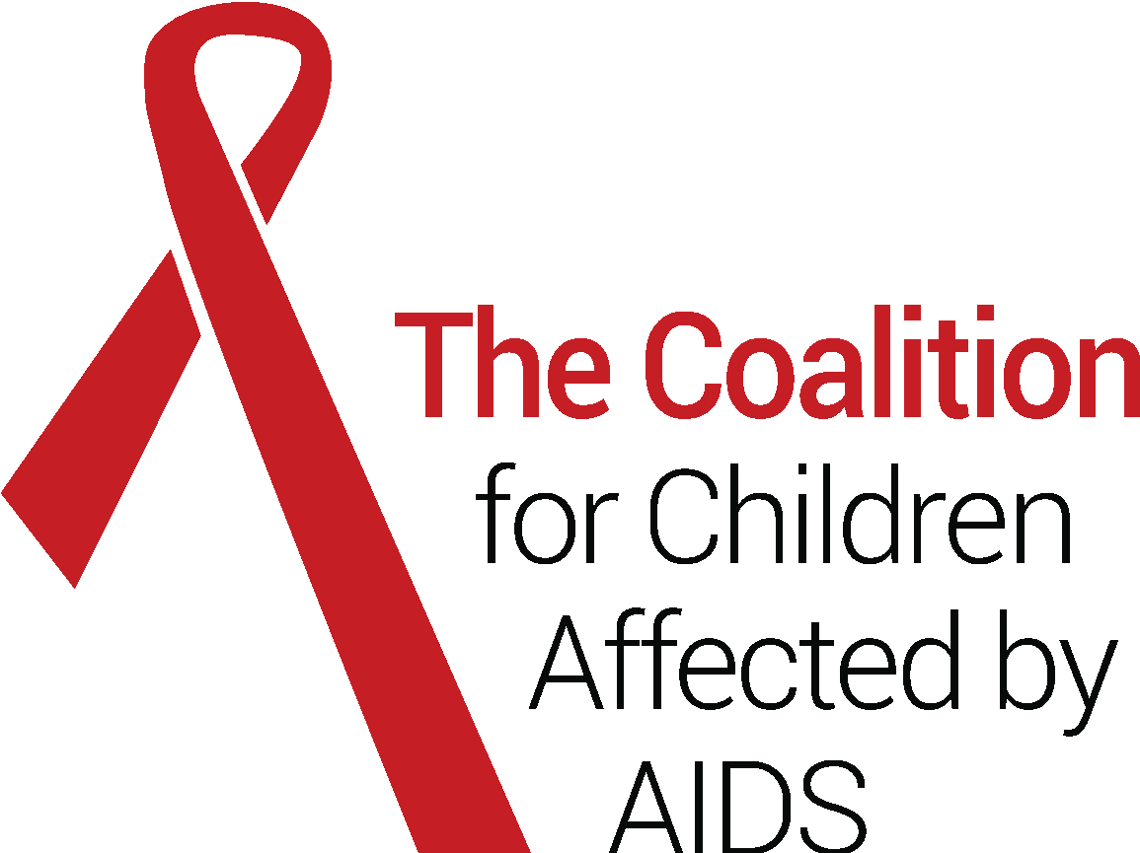

CREATING A ROADMAP OF INVESTMENT TO END AIDS IN CHILDREN BY 2030

Terms of Reference (15th November 2023)

- Summary
The Coalition for Children Affected by AIDS (the Coalition) is creating a roadmap of financial investment to end AIDS in children by 2030. It will look at financing in the priority countries of The Global Alliance to End AIDS in Children; showing what is being spent, where, on whom, to what effect, and what the gaps are. We will analyse expenditure in select countries that provide insights for Sub Saharan Africa as a whole. And we will foster a dialogue between public and private donors, governments, and civil society in 2024.

This roadmap is the second phase of a longer-term project. Since 2021, the Coalition has chaired the Global Working Group on Financing for Children and Adolescents Affected by HIV. And in 2022, it published the first global analysis of trends in international donor expenditure, setting out a global picture of the level of investment for children and adolescents and major areas of programming.

This next phase builds upon these successes, by drilling down to reveal how funds are being invested at the country level and where the gaps are. We will produce action-oriented investment data, a methodology for tracking spending, and – most crucially – a dialogue on financing to end AIDS in children.

For more information please contact Corinna Csaky Corinna.csaky@childrenandHIV.org.

- Rationale
There is an urgent need for this project. We have unprecedented political momentum, strong partnerships and the imminent expiration of 2025 HIV targets for children. We must not miss this moment. HIV remains a major threat to children and adolescents and a violation of their rights. Every two minutes an adolescent girl or young woman is newly infected with HIV; almost half (43%) of children living with HIV are not on treatment; and exposure to HIV and the wider social and economic impacts of the disease are holding back generations and hampering progress towards the Sustainable Development Goals. This is a travesty, not least because HIV in children is now preventable and treatable.

The Global AIDS Strategy 2021-26 highlights the critical importance of addressing the needs of HIV-affected children and adolescents. In terms of realising their rights, and for ending the AIDS epidemic as a whole. Established in 2022, The Global Alliance to End AIDS in Children supports the Global AIDS Strategy. It galvanizes political and financial support from UN agencies, major donors, NGOs and governments, all of whom have aligned behind a common framework. The Alliance has chosen 12 priority countries from Sub Saharan Africa in its first phase. All are in the process of creating detailed workplans and associated budgets, which are also the basis for their latest grant applications to PEPFAR and Global Fund.

However, the lack of financial transparency for children and adolescents makes it difficult to know whether and where plans are being funded. Money is also being wasted, through siloed approaches, missed opportunities to invest in more cost-effective solutions, and poor targeting of those specific populations of children at greatest risk. While many funders – governments, donors, and private trusts and foundations - express their commitment to vulnerable children, adolescents and caregivers in policies and strategies, they do not track funds for them in sufficient detail to know whether and where this commitment translates into action. This also means that they cannot be held to account.

This is especially important as we seek to address the needs of those children left behind. These include adolescent parents and their children, children associated with ‘key populations,’ and other children and caregivers facing chronic social and structural exclusion. The HIV response needs to adopt need new strategies and approaches to serve these populations, which are grounded in differentiated service delivery. We have the evidence; we know what works; what we need now is to deliver it at scale.

We are operating in a resource-constrained environment. Now, more than ever, it is important to know that money is being allocated wisely. We cannot expect increased resources for HIV. Rather, we must maximize what we have. Funders, and the communities they work with, need to know how much is being spent, on what, where, to what effect, and what the gaps are. Only then can they be sure of value for money, and that policies and commitments are being acted upon. And where investment opportunities remain.

We acknowledge that funding for HIV-affected children comes from a variety of sources. Domestic financing is especially critical since it is the most sustainable and locally accountable source of funding. While PEPFAR and The Global Fund may be the largest international funders to HIV, other donors are also strategically important, including SIDA, Germany, Switzerland, the UK, Norway, Australia, and major foundations such as the Bill and Melinda Gates Foundation, ViiV Healthcare, Gilead and the Children’s Investment Fund Foundation. Furthermore, it is not just ‘HIV funding’ that needs to be considered. Funding streams for social protection, sexual and reproductive health, universal health coverage, primary health care, maternal and child health, immunizations, early childhood development, gender equality, mental health and violence against women and girls are contribute to children affected by HIV to varying degrees.

Since 2021, the Coalition has been working to improve financial transparency and efficacy for children and adolescents affected by HIV. It established the Global Working Group on Financing for Children and Adolescents Affected by HIV – a group of UN, donor, academic and NGO thought leadership. And in 2022 the Coalition published a report revealing – for the first time - global trends in donor funding for children and adolescents affected by HIV. Already, this endeavour has generated important results. Not least, PEPFAR developed and published a new global expenditure report on children and adolescents; and the Global Fund adapted its Modular Framework to make children and adolescents more visible in its financial and impact monitoring. Moreover, the Working Group generated unprecedented dialogue, transparency and collaboration.

This new initiative will build upon on these successes. It will move beyond global data and drill down to the country level. Although the analysis will focus on select countries, the findings will provide insights for Sub-Saharan Africa as a whole. And the methodology, process and relationships forged can then be applied to all settings. It will be achieved through close collaboration with the Global Working Group on Financing for Children and Adolescents Affected by HIV, including the World Health Organization, UNAIDS, Unicef, PEPFAR, the Global Fund and Avenir Health.

- Outcomes
Information for action: Funders of all kinds - governments, private trusts and foundations and bilateral and multi-lateral donors - will be more informed on where and how funds are being used and the opportunities for further investment. Advocates will be better informed of what areas of programming require further funding, and to hold funders to account. And all stakeholders will benefit from a methodology for tracking investments in children and adolescents affected by HIV and AIDS. This will pave the way for longer-term financial tracking in the priority countries of the Global Alliance to End AIDS in Children.

Dialogue: Key actors from across the UN, funder, government, academic and NGO communities will forge strategic relationships and consensus for improving financing for children and adolescents affected by HIV.

- Outputs
  - An analysis of funding in select countries of the Global Alliance to end AIDS in children, accompanied by policy reflections and recommendations for financing across the Sub-Saharan African region.
  - A methodology to support continued financial analysis in any country context.
  - At least two meetings of the Global Working Group on Financing for Children and Adolescents Affected by HIV.
  - High profile and strategic dissemination activities - to be determined – E.g. at the AIDS conference in July 2024 in Berlin, Germany, at a meeting of the UNAIDS Programme Coordinating Board, at a meeting of the private trusts and foundations associated with Funders Concerned About AIDS.

- What specific questions will we answer?
The overarching question that this initiative will answer is: Do governments and donors need to reallocate their funds in order to yield the best results for HIV-affected children and adolescents, and, if so how?

To answer this, we will for each select country identify:

  - How much funding is required? As laid out in the new national plans and budgets of the Global Alliance to End AIDS in Children, what areas of programming are required to close the treatment gap for children and how much do they each cost?
  - How much is being spent and on what? What is the expenditure against each area of programming?
  - Where is this money coming from? What proportion do the government, multilateral, bilateral and private donors make? And how is this spread across their various budget lines for HIV, health, social and economic programming?
  - Are there funding gaps and, if so, where? Which budget lines are under-resourced currently and by how much?
  - What is the return on investment for finding and treating the ‘missing’ children living with HIV? How many more lives and how much money are saved from finding and treating HIV in childhood rather than later on?

This analysis will identify and separate out funding for biomedical HIV programmes from funding for broader social and economic programmes to strengthen health systems or to enable children affected by HIV to overcome barriers to accessing HIV support. Biomedical HIV programmes include, pediatric HIV testing and treatment, including early infant diagnosis and case finding of the 'missing’ children living with HIV; programmes to eliminate vertical transmission (PMTCT). Social and economic programmes include, social care for orphans and vulnerable children; social protection; mental health support; support for early childhood development; education; and programmes to tackle violence against women and girls.

We will also look at funding not only from ‘HIV’ expenditures, but also from expenditures on programmes serving the wider population, which also impact on children and HIV. These include, funding for national programmes on social protection, sexual and reproductive health, universal health coverage, primary health care, immunizations, early childhood development, education, gender equality, mental health, tackling violence against women and girls. We will agree a proportion that can be reasonably attributed to serving children affected by HIV.

Where the data allows, this analysis will reflect on the following additional questions. However, due to anticipated data limitations, these will be inferred insights only.
  - Which children and adolescents currently benefit from funding for HIV? For example, which age categories (0-4, 5-19, 10-14, 15-17); which sub-populations (such as adolescent parents, the children of key populations, children with disabilities etc.); and how much is serving girls vs boys.
  - What kind of interventions are receiving the most/least support within each area of programming?
  - What proportion of investments for children and adolescents are for community-driven programming? These include community-based organisations and community health workers delivering services, peer-to-peer support, community-led advocacy, and community outreach and research for children and adolescents affected by HIV.
  - What is the cost of inaction? Without dedicated funding for children and adolescent affected by HIV how many new infections would there be and how many lives would be lost by 2030?
  - What proportion of non ‘HIV funds’ are serving children and adolescents affected by HIV? To what extent are broader health, social and economic expenditures serving HIV-affected children and what is the funding shortfall in meeting their overall needs? This will give us an indication of the funding gaps as children and HIV become integrated into a broader health, social and economic areas of responsibility.
  - In light of the multiple benefits generated by HIV, health, social and economic interventions, what proportional cost-share should each sector make? If different ministries were to pool their funds behind common interventions for HIV-affected children that serve multiple outcomes, what would the proportional cost-share be from each sector?
  - Are there hidden incentives driving the gap between children accessing treatment (57%) and adults (77%) and, if so, what are they?

- What sources of data will we use to answer these questions?
It is vital that the same sources of data are used across all selected countries. In this way, we can draw comparisons between them and conclusions for other countries in the Sub-Saharan region as a whole. Limitations around data availability is likely to be a major factor in deciding what questions we can reasonably answer and where.

We will use the national plans and associated budgets of the Global Alliance to End AIDS in Children as our starting point for identifying what funding is required in each country and what it needs to be spent on. We acknowledge that Global Alliance plans do not always reflect the full cascade of programming required as they necessarily prioritize select core components only. However, knowing whether these core components are adequately resources is a useful starting point.

We anticipate that the following additional data sources will answer our questions and be widely available:
  - 2022 National government budget and expenditure reports – such as this one from South Africa.
  - 2022 PEPFAR country operational plans – such as this one from South Africa.
  - PEPFAR Panorama Spotlight detailing 2022 country disbursements
  - UNAIDS Financial Dashboard.
  - The Global Fund Funding Landscape Tables completed by countries applying for funds.
  - 2023 Global Fund national grant applications and the forthcoming associated disbursements.
  - Recent National AIDS Spending Assessments. N.B. only the following Global Alliance priority countries have conducted them in the last 5 years: Nigeria 2018; Uganda 2019; South Africa 2020; and Mozambique 2018).
  - Modelling of cost savings and other benefits of case finding and early treatment generated by the Cost-Effectiveness of Preventing AIDS Model (CEPAC).
  - The Funders Concerned About AIDS annual review of HIV spending from private trusts and foundations.
  - Sherr, C et al (2023) Understanding Accelerators to Improve SDG-related outcomes for Adolescents
  - Watts, C (2018) Two Years and Counting: Breaking down silos to reach the most vulnerable.

N.B. Since most funding is recorded along broad lines – such as ‘social care,’ ‘education’ or ‘health’ – we will need to agree in the methodology what proportion of broader expenditure can be reasonably attributed to serving HIV-affected children and adolescents. This includes expenditure on strengthening health systems and human resources.

N.B. The issue of whether there is a funding gap is critical. But it is also complex. There is no universally agreed method for calculating how much funding is needed to achieve HIV and other targets. Instead, each country decides what essential services are required to meet the needs of the local child population and how much they cost. As part of the analysis, we will need each country to elaborate on their methodology for calculating the level of need and the corresponding budget for the Global Alliance to End AIDS in Children.

- Which Countries?
The research will focus on select priority countries. This is felt sufficient to draw conclusions for the Sub Sahara Region as a whole. And, with research in each country estimated to cost at least $5,000, this keeps the research to a reasonable amount.

The selection of countries was made using the following criteria:
  - Amongst the 12 priority countries of the Global Alliance to end AIDS in Children and the seven PEPFAR PMTCT Accelerator programme countries
  - Countries that have already collected sufficient data to support this analysis.
  - Countries that are interested to take part in this process and have the capacity to play an active role.
  - A combination of East, West, Central and Southern African countries
  - At least one country where domestic funding is most prevalent
  - At least one country where international donor funding is more prevalent
  - Of strategic political importance for Africa
  - Priority countries for PEPFAR and the Global Fund, as well as for other donors that prioritize children and adolescents including UK, Norway, Sweden, Switzerland and Germany.
  - A range of low, low-middle, and upper-middle income countries.
  - At least one country with a high proportion of children living with HIV
  - At least one non-Anglophone country
  - Where co-sponsors are active and can support in-country research and advocacy

South Africa, Kenya, Mozambique, Zimbabwe, Nigeria and Uganda have all been identified as meeting the above criteria. Although at this stage we have not yet confirmed the final selection. We need to prioritise three countries - or more if further funding is available. The Coalition welcomes additional sponsorship to cover research in countries.

We will start with South Africa and Kenya, not least because they have developed their national plans and budgets within the Global Alliance to end AIDS in Children. We will take a sequenced approach - starting with one country and improving upon the methodology for the next.

- Process & Timings
We are aiming for a first draft by 1 May 2024. The Coalition has commissioned Avenir Health to support the country research and analysis. John Stover will be the lead author. And Avenir will identify and oversee a consultant in each country. We anticipate that each country consultant will collect and analyse data from and facilitate a dialogue with the country lead for the Global Alliance to End AIDS in Children; with the national government financing lead; with the different ministries whose area of responsibility relates to children and HIV; with major donor representatives in country; and with the Country Coordinating Mechanism.

The Coalition will convene at least two meetings of the Global Working Group on Financing for Children and Adolescents Affected by HIV to support this initiative. Including a meeting in early 2024 to review the draft findings and to generate an advocacy agenda from them. The Coalition welcomes partnership to co-host these events. We will also support children and adolescents affected by HIV and their caregivers to participate in the research process.

The aim is to host a broader dialogue about the findings and recommendations at key strategic opportunities in 2024. For example, around the AIDS conference, a meeting of the UNAIDS Programme Coordinating Board, and a meeting of the members of Funders Concerned About AIDS.

https://childrenandhiv.org/
https://www.childrenandaids.org/global-alliance
https://bit.ly/DonorPolicyReport
UNAIDS (2022) In Danger UNAIDS Global Update 2022 https://www.unaids.org/en/resources/documents/2022/in-danger-global-aids-update
UNAIDS (2023) The Path that ends AIDS: The Global AIDS Update 2023 https://www.unaids.org/en/resources/documents/2023/global-aids-update-2023
https://www.unaids.org/en/Global-AIDS-Strategy-2021-2026
https://www.childrenandaids.org/global-alliance
Angola, Cameroon, Côte d'Ivoire, The Democratic Republic of the Congo (DRC), Kenya, Mozambique, Nigeria, South Africa, Tanzania, Uganda, Zambia, and Zimbabwe
https://bit.ly/DonorPolicyReport
https://www.iasociety.org/conferences/aids2024
https://www.treasury.gov.za/documents/national%20budget/2022/review/FullBR.pdf
https://www.state.gov/wp-content/uploads/2022/09/South-Africa-COP22_SDS.pdf
https://data.pepfar.gov/
https://hivfinancial.unaids.org/hivfinancialdashboards.html
https://www.theglobalfund.org/media/5747/fundingrequest_fundinglandscape_table_aa.xlsx
https://www.unaids.org/en/dataanalysis/knowyourresponse/nasacountryreports
https://www.massgeneral.org/medicine/mpec/research/cpac-model
https://www.fcaaids.org/inform/philanthropic-support-to-address-hiv-aids/
Sherr L, Haag K, Tomlinson M, Rudgard WE, Skeen S, Meinck F, Du Toit SM, Steventon Roberts KJ, Gordon SL, Desmond C, Cluver L. Understanding accelerators to improve SDG-related outcomes for adolescents-An investigation into the nature and quantum of additive effects of protective factors to guide policy making. PLoS One. 2023 Jan 6;18(1):e0278020. doi: 10.1371/journal.pone.0278020. PMID: 36607964; PMCID: PMC9821522. https://pubmed.ncbi.nlm.nih.gov/36607964/
https://childrenandhiv.org/wp-content/uploads/2018/09/Watts-Two-Years-and-Counting-IAS2018-final.pdf

